Supernatural Menagerie Theatrical Experience Summary v.1.0
02/10/2021
Natalia Barreto, Roderick Pope, Katie Slinkosky

The Supernatural Menagerie

High Concept
Shrouded within a mysterious warehouse dedicated to the supernatural, guests discover and decipher the mystery of a daunting figure and his association with haunted locations scattered across the country, while trying to answer the question, who is Nox?

Welcome my dear guests! I am so happy you’ve joined me on this special tour of my Supernatural Menagerie! Here you’ll board the Queen Mary, walk down an abandoned cell block at the Eastern State Penitentiary and wander the endless halls of the Winchester House. Here you’ll learn of their haunted histories and interact with the spirits that call these fortresses of distress home, but don’t stray from the path provided to you, or the consequences will be, severe. Your new adventure awaits!

As guests interested in the supernatural, your desire to learn and explore haunted locations has brought you to the Supernatural Menagerie. Shrouded in mystery, a figure calling himself Nox, offers you the task to discover who he is, but his offer isn’t as genuine as you’ve been led to believe; hoping to forever haunt his invited guests, including you. Wandering through the haunted vessel, the Queen Mary, the abandoned Eastern State Penitentiary, and the mysterious Winchester House, you learn the history of these locations through exhibits and spirits that once inhabited these domains. Ensure you listen to their words and heed their advice, for they are your key to discovering Nox’s treacherous plot.

Three of history’s most famous haunted locations are resurrected in this new theatrical walkthrough experience, The Supernatural Menagerie. Discover the truth hidden by Nox, or this innocent trip will be your be last.

Attraction Description/ Beat List

- Exterior Show Building: Abandoned rectangular warehouse in New York City; brown and tan brick; wooden panels, open and closed on either side of the numerous cracked windows spanning the front, and green stains running down the front from rainwater. A new pristine sign, The Supernatural Menagerie, is displayed above the two rotting doors on the far left side of the building.

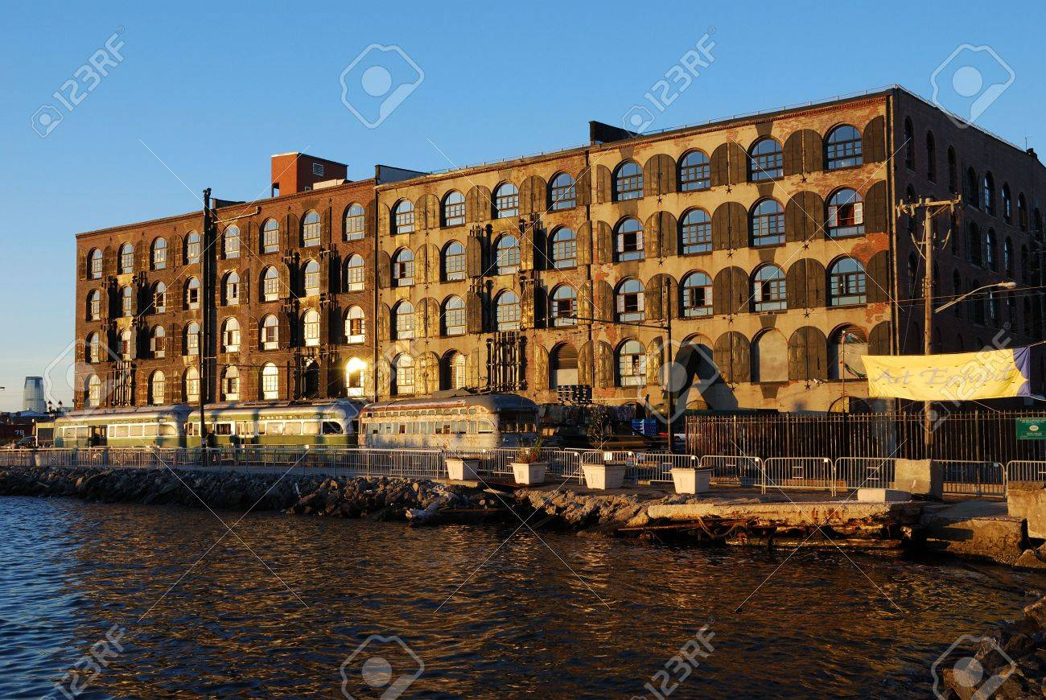

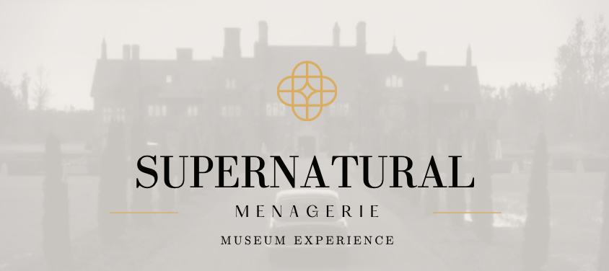

- Lobby: Interior show building: small lobby with a large skylight above; two large wooden doors on the right wall; a new small reception desk sits in the middle; numerous rusting metal benches sit against the wall. Graffiti decorates the walls; large overgrown vegetation sprouts from the floor. The sound of single droplets of water dripping echoes throughout the space.

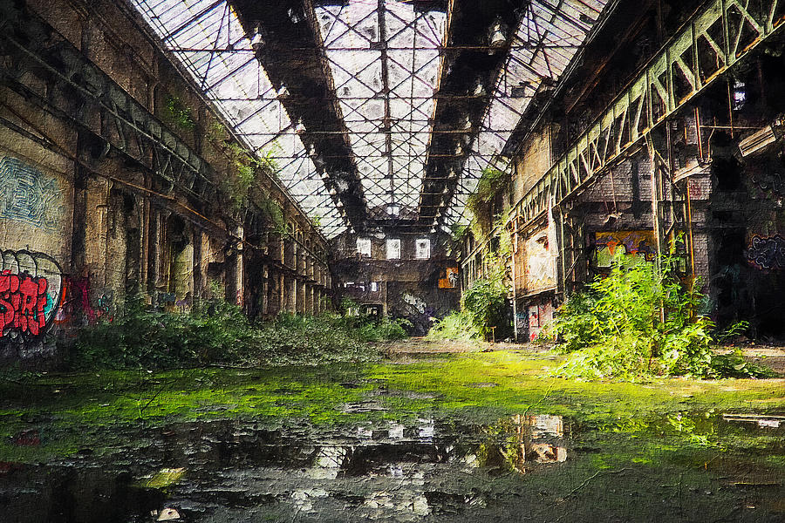

- Foyer: The path begins through the two large wooden doors, opening into a decrepit foyer. A large mirror capable of opening at the center, acts as a doorway, is on the opposite side; a tiny balcony is above the mirror with a spiral iron staircase. Empty picture frames hang on three walls. Nox walks onto the balcony, dressed in all black with only a purple tie and red eyes.
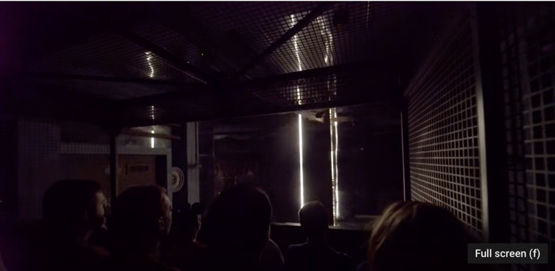

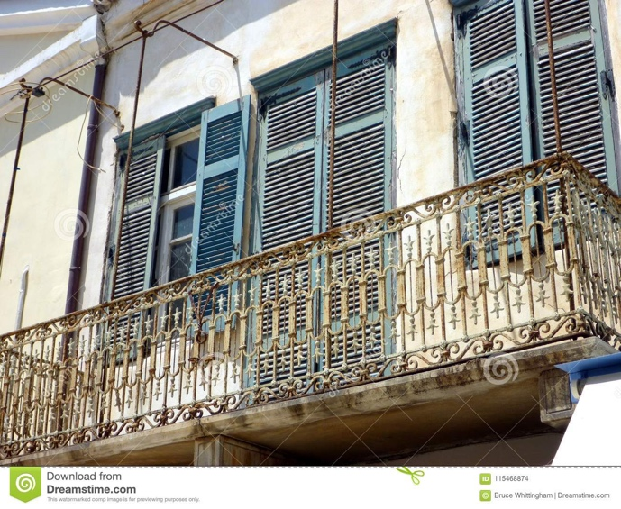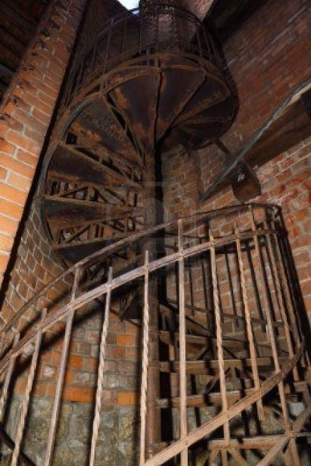

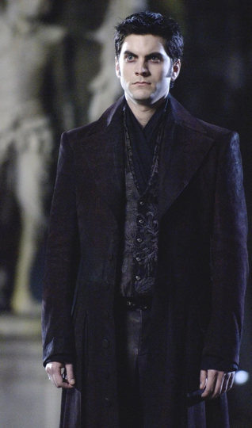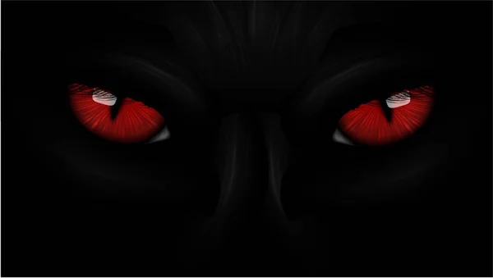

- Queen Mary Ballroom: The path enters the Queen Mary’s ballroom. Elegant lights hang from the ceiling; a large wooden dance floor; exhibits and artifacts from the real Queen Mary on all four walls. Two tall circular pillars on either side of the dance floor; small stage and large mural with small fireplace are on opposite sides of the room. Spirits wander the room and Nox, dressed as a captain interact with guests. The path exits the room through a push-able mirror outlined in purple.

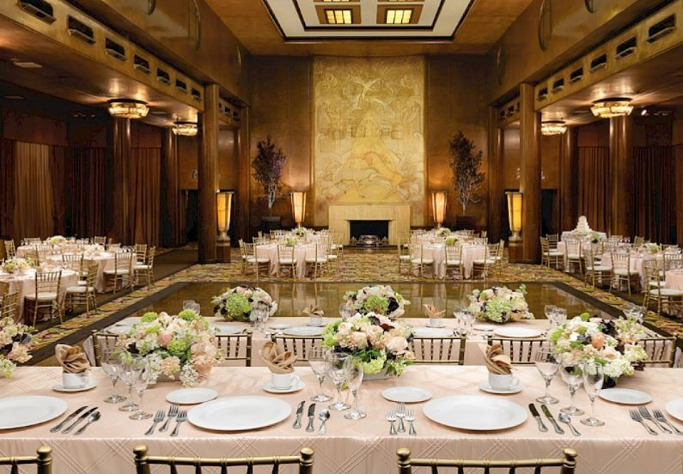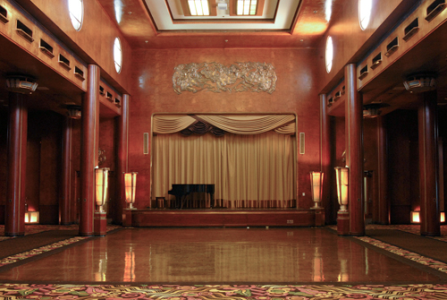

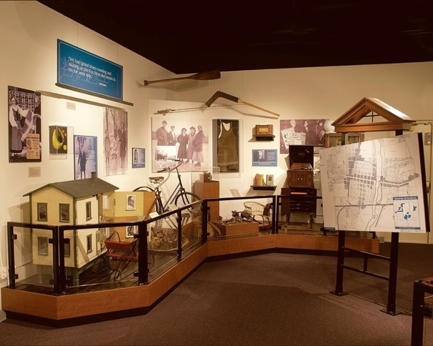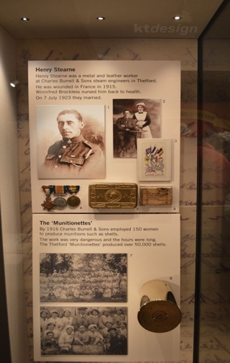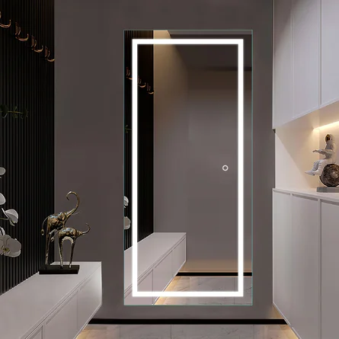

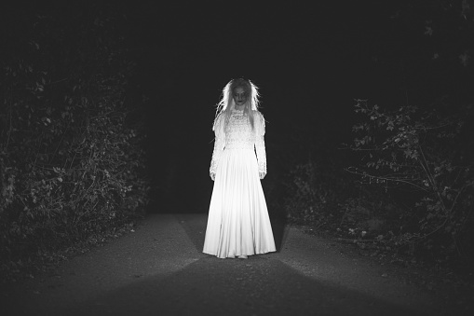
- Eastern State Penitentiary: The path enters an abandoned cell block; four cells on either side; sliding wooden door for each cell. Walls are crumbling; overhead skylight and overarching lights above the cells. Within each cell is either an exhibit or actor; Warden Nox walks the cellblock. The path leads to the final cellblock with a mirror outlined in white.

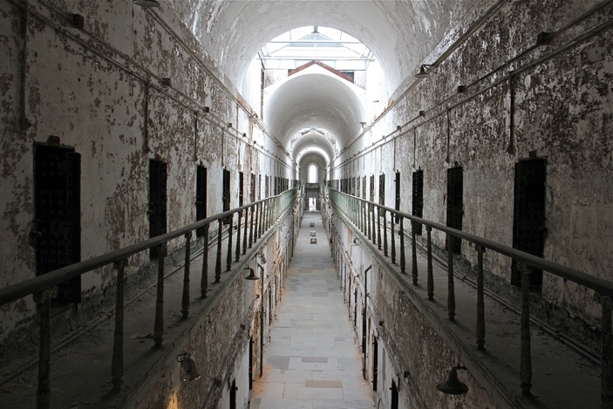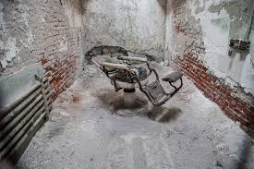

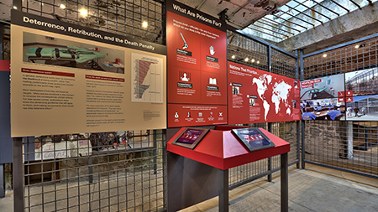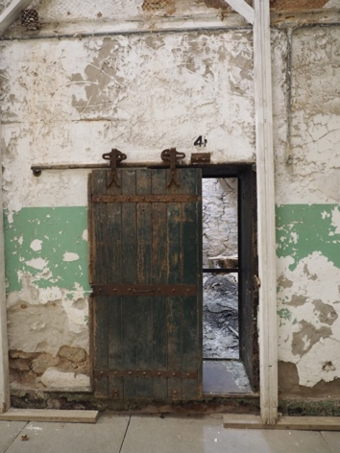

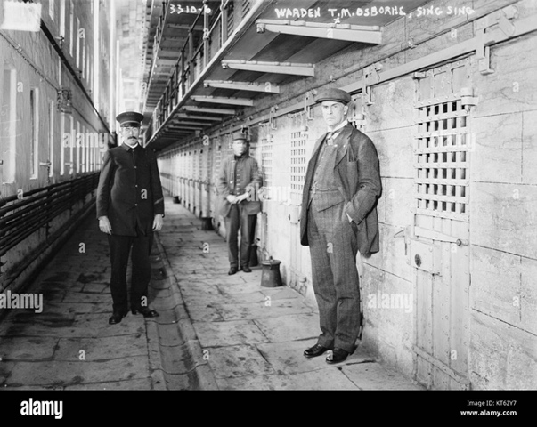
- Winchester House: The path opens to a staircase with 44 steps and seven turns leading to Sarah Winchester’s extravagant bedroom. The path wanders through her house, passing exhibits detailing its history and spirits and famous parts of the house including, the Hall of Fires, an overgrown conservatory with dead and dried plants, pass two doors: one that opens to a brick wall and another that opens to a staircase leading to the ceiling. The path continues into a Venetian dining room with stained glass windows and a mirror outlined in white.

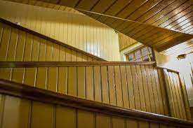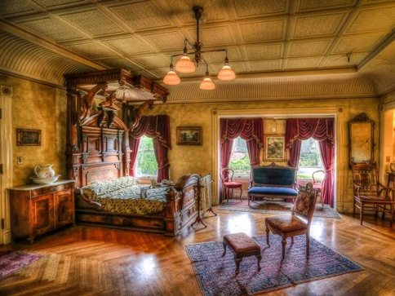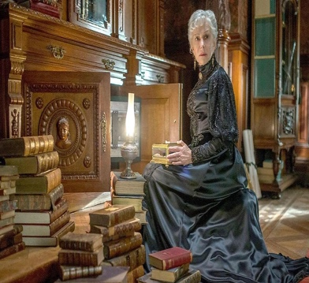

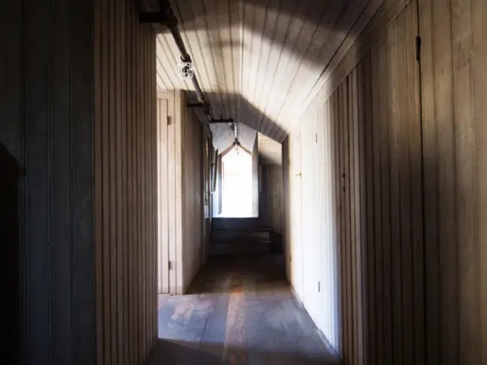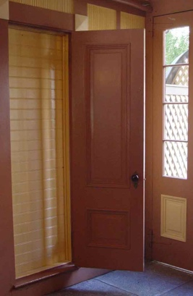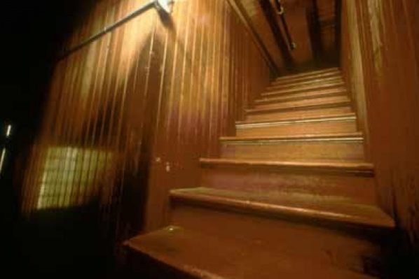

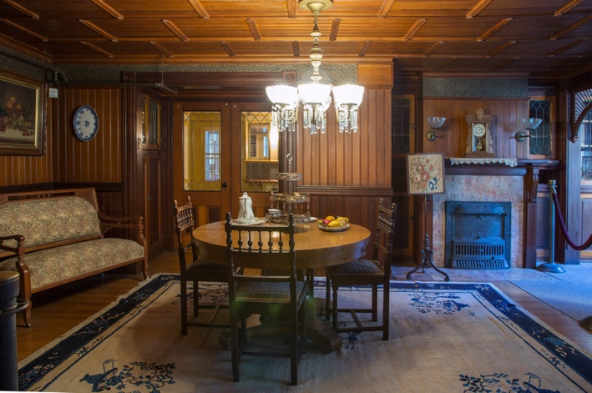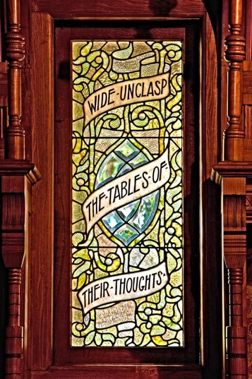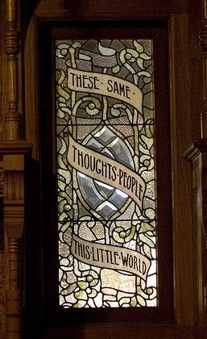
- Nox’s Lair: The path enters Nox’s Lair littered with ‘trophies’ from haunted locations around the world, including facts from each one. In the back, almost hidden behind the artifacts, is a picture accompanied with a paragraph detailing Nox’s first haunting and a gavel originating from the Salem Witch Trials. The path ends with a large mirror outlined in white, leading back to the warehouse.

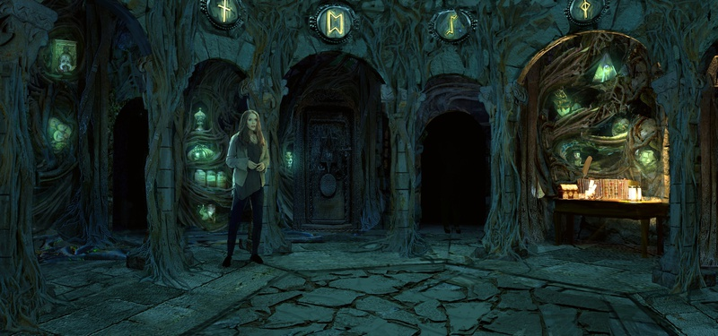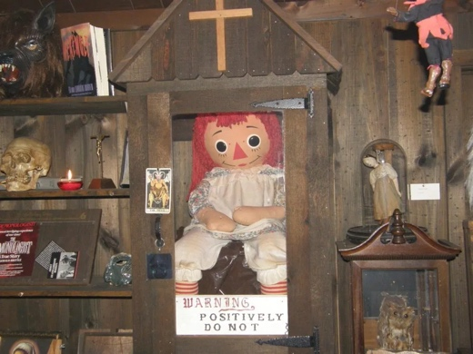

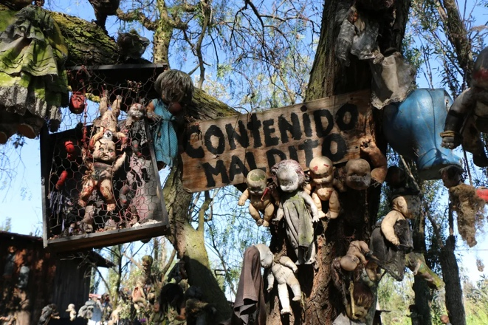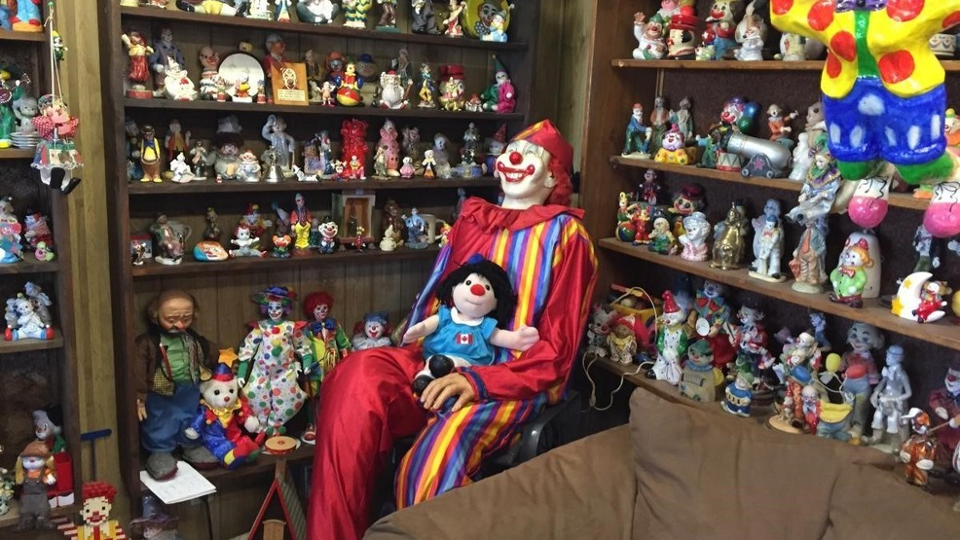

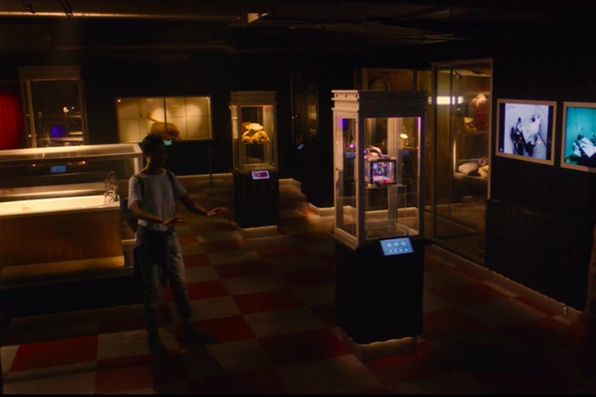

- Foyer: The path reenters the foyer, but this one is mirrored. The balcony and spiral staircase remain, but the empty frames now depict random people and objects from throughout history that Nox has impersonated. Nox appears on the balcony, no longer wearing a suit, but a colonial suit and curly black wig, informing everyone he was born Reverend Samuel Parris, the man who sentenced countless women to death for being witches. Nox dismisses them.

